**UML Diagrams & Descriptions for the LOAFR System:**

By: Wil Bishop, Anakin Nolette, Trent Young, Ashlyn Pietrowski

—-------------------------------------------------------------------------------------------------------------------------

**Context Diagram:**

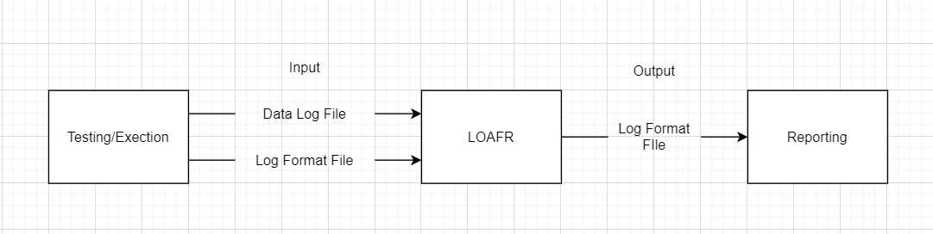

**How to Read:**

The boxes represent the objects which interact.

The arrows represent the interactions between objects.

The text on the arrow represents the type of files being shared.

**Narrative description:** An output from a testing/execution system of the form “data log file” or “log format file” is sent to the LOAFR system. Once the LOAFR system has processed the data log file or log format file, it sends a log format file to the reporting system that will display the results of the LOAFR system to the user on the screen.

—---------------------------------------------------------------------------------------------------------------------------------------------------------

**Sequence Diagram 1: Searching, sorting, filtering**

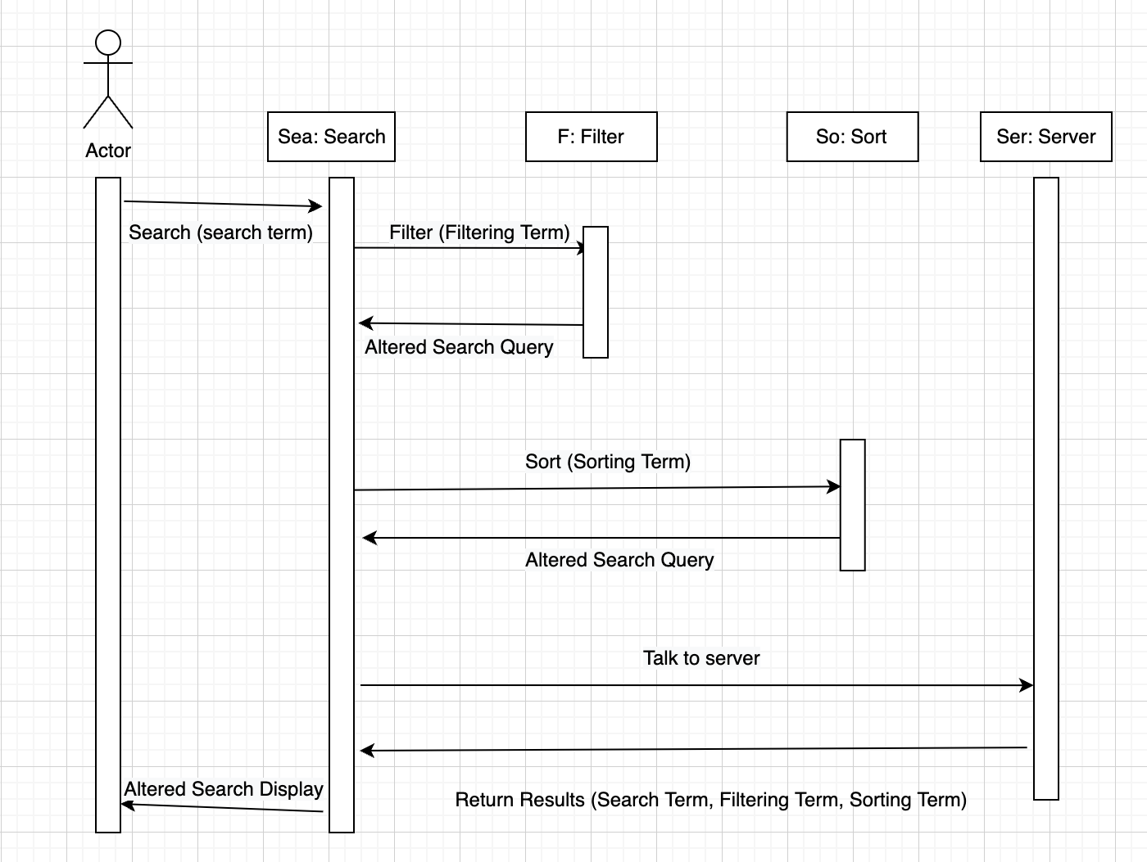

**How to Read:**

The stick figure represents the actor.

The rectangular boxes of text represent the actions that the user can request from the system.

The arrows represent the direction of input and output.

**Narrative Description:** The actor (represented by the stick figure) enters a search term in either the search bar, the filter bar, or the sorting bar, depending on which action they would like to perform. The initial screen will contain the data that the user may search, sort, or filter through. If the input is in the searching bar, the search term is given to the system, where the system locates all data items that match the search query. All these items are returned to the user. If the input is in the filter bar, all the data items are filtered based on the input, and the data that is relevant is highlighted on the screen. If the input is in the sorting bar, the data is sorted based on the query, and only the relevant data is returned to the user on the screen.

—---------------------------------------------------------------------------------------------------------------------------------------------------------

**Sequence Diagram 2: Searching, sorting, filtering**

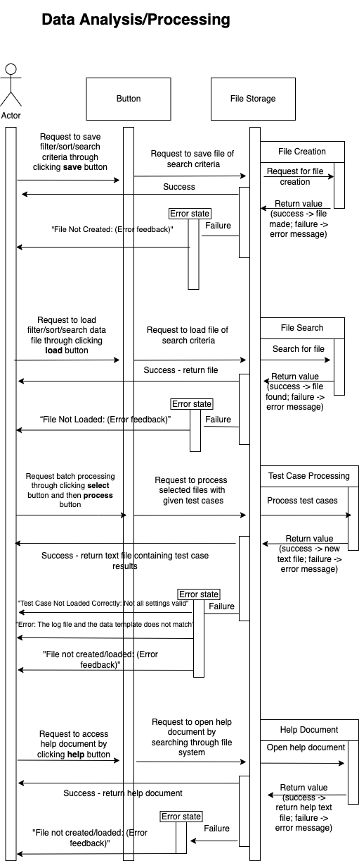

**How to read:**

The stick figure represents the actor.

The rectangular boxes of text represent the actions that the user can request from the system.

The arrows represent the direction of input and output.

**Narrative Description:** The actor (represented by the stick figure) requests to save, load, or process criteria, or the actor requests to open the help document. This request is made by clicking on a button that corresponds to the type of request being made. The request is forwarded to the file system, where the system either creates or searches for the requested file. The underlying process is completed and gives a return value; either success or failure. On success, a file or success message is returned. If the process returns ‘failure’, the error state is activated, and a specific error message is displayed that is relevant to the initial stimuli.

—---------------------------------------------------------------------------------------------------------------------------------------------------------

**Structure Diagram**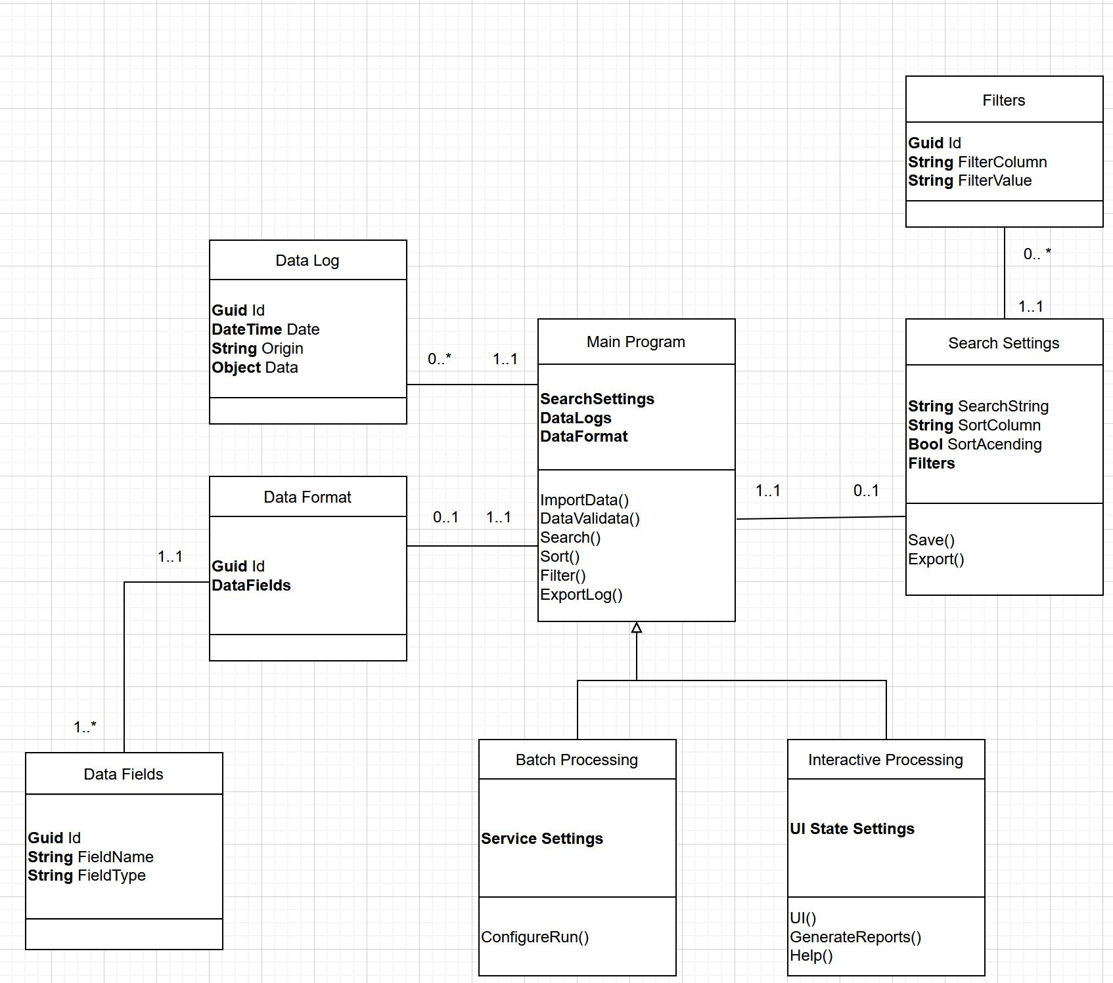

**How To Read:**

Each large box is a class and the lines between them represent how they relate to one another. Batch Processing and Interactive Processing are both extensions of the generalized Main Program. For each relationship, the numbers that are adjacent to the class determines their multiplicity in the format MIN..MAX (* being infinite)

Data Log, Data Format, and Data Fields are related to inputted data logs.

Search Settings and Filters are for holding the search criteria for the program. It includes the functions that would fulfill function requirements 4.7 and 4.8. The Main Program Class holds information and methods that are related to the main function of the requirement. It includes the function that would fulfill the function requirements 4.1 - 4.5. The batch processing will fulfill the requirements of 4.9. The interactive processing will fulfill the requirements 4.6 and 4.10

# **Narrative Description:** There are six classes: Data Log, Data Format, Data Fields, Main Program, Filters, and Search Settings. The Main Program is the main part, with the other classes being eventually related to it. It has the attributes of Data Logs, Data Format, and Search Settings, which are related to the previous classes. It also has the methodsImportData() DataValidate(), Search(), Sort(), Filter(), and ExportLog(). It can access many Data Log classes, which have an Id, Date, Origin, and an Object for its data. The Main Program can also have a Data Format Class. The Data Format has an Id and DataFields. There can be many DataFields for each Data Format and the DataFields have an Id, FieldName, and FieldType attributes.

In addition, the Main Program can have a Search Settings Class. This class has a SearchString, SortColumn, SortAcending and Filter Fields. It has Save() and Export() methods. It can have many Filters, which has an ID Filter Column and FilterValue attributes. Finally, the Main Program has two subclasses: Batch Processing and Interactive Processing. Batch Processing has the ServiceSettings attribute and ConfigureRun() method. The Interactive Processing subclass has UIStateSettings attributes and the UI(), GenerateReports(), and Help() methods.